EXPT NO: 10 | /BUILDING A SIMPLE LLM CHATBOT USING STREAMLIT/GRADIO
DATE: 14/10/16 | /BUILDING A SIMPLE LLM CHATBOT USING STREAMLIT/GRADIO

PRE-LAB QUESTIONS (PROVIDE BRIEF ANSWERS TO THE FOLLOWING QUESTIONS)

- What is a Large Language Model (LLM)?
A Large Language Model (LLM) is an AI model trained on large amounts of text to understand and generate human-like language.

- What is the role of the Transformer architecture in modern LLMs?
The Transformer architecture helps LLMs understand the context and relationships between words. It uses a mechanism called self-attention to identify important information. It improves the accuracy and efficiency of language processing.

- What is a prompt, and how does it influence an LLM's response?
A prompt is a question or instruction given to an LLM. It guides the model in generating a response. Clear and specific prompts usually produce more relevant and accurate answers.

- What is the difference between a chatbot and a conventional rule-based program?
A chatbot interacts with users through conversations and may use AI to understand queries. A conventional rule-based program follows predefined rules and instructions. Chatbots can handle varied questions, while rule-based programs are limited to programmed conditions.

- What are Streamlit and Gradio used for?
Stream lit and Gradio are Python frameworks used to build interactive web applications. They help developers create user interfaces for machine learning and AI models. They allow users to interact with models without writing code.

AIM
To build a simple chatbot or AI application using a Transformer-based Large Language Model (LLM), process user prompts, generate responses, and deploy the application using Streamlit or Gradio.

SOFTWARE REQUIREMENTS
- Python
- Google Colab / Jupyter Notebook / Local Python environment
- Hugging Face Transformers
- PyTorch (or another supported model backend)
- Streamlit or Gradio
- GitHub (for version control and submission)
- A web browser
- An LLM API key, if using a hosted model API

OBJECTIVES
Students will be able to:
- Understand the basic working of Transformer-based LLMs.
- Select and load a suitable pretrained language model or connect to a hosted LLM API.
- Accept user input through a prompt-based interface.
- Generate and display responses from the selected model.
- Build a simple chatbot interface using Streamlit or Gradio.
- Maintain conversation history where supported.
- Test the chatbot with different prompts and evaluate the relevance of its responses.
- Run and demonstrate the deployed application.

PROCEDURE
PART A: ENVIRONMENT SETUP AND MODEL SELECTION
Perform the following tasks:
- Create a Python notebook or project folder.
- Install the required libraries, such as transformers, torch, and either Streamlit or Gradio.
- Choose a suitable pretrained instruction-following or conversational model or select a hosted LLM API.
- Read the model documentation and check its hardware, memory, access, and usage requirements.
- Load the model and tokenizer or configure the API client and store the API key securely as an environment variable.
- Test the setup with one simple input prompt.
PART B: PROMPT HANDLING AND RESPONSE GENERATION
Perform the following tasks:
- Define a function that accepts a user message as input.
- Prepare the prompt in the format required by the selected model or API.
- Pass the prompt to the model and generate a response using suitable generation settings.
- Decode and display the generated response clearly.
- Handle empty input and basic runtime or API errors.
- Test the function using at least five different prompts and record the responses.

PART C: BUILDING THE CHATBOT INTERFACE
Perform the following tasks:
- Choose either Streamlit or Gradio to create the user interface.
- Add a text box or chat input for entering user messages.
- Display the user message and the model-generated response in the interface.
- Maintain conversation history if supported by the selected model and interface.
- Add a clear-chat or reset option if appropriate.
- Run the application locally and test the interaction from a web browser.

PART D: TESTING AND DEPLOYMENT
Perform the following tasks:
- Test the chatbot with factual, conversational, and task-oriented prompts.
- Check whether the responses are relevant, readable, and consistent with the prompts.
- Identify any incorrect, biased, or unsafe responses and note the limitations.
- Deploy the application using an available hosting option supported by Streamlit or Gradio or demonstrate it locally if deployment access is unavailable.
- Do not upload API keys or other secrets to GitHub; use environment variables or the hosting platform's secrets settings.
- Save the source code, requirements file, screenshots of the interface, and sample outputs.
- Include the GitHub repository link and the application link, if publicly deployed, in the submission.
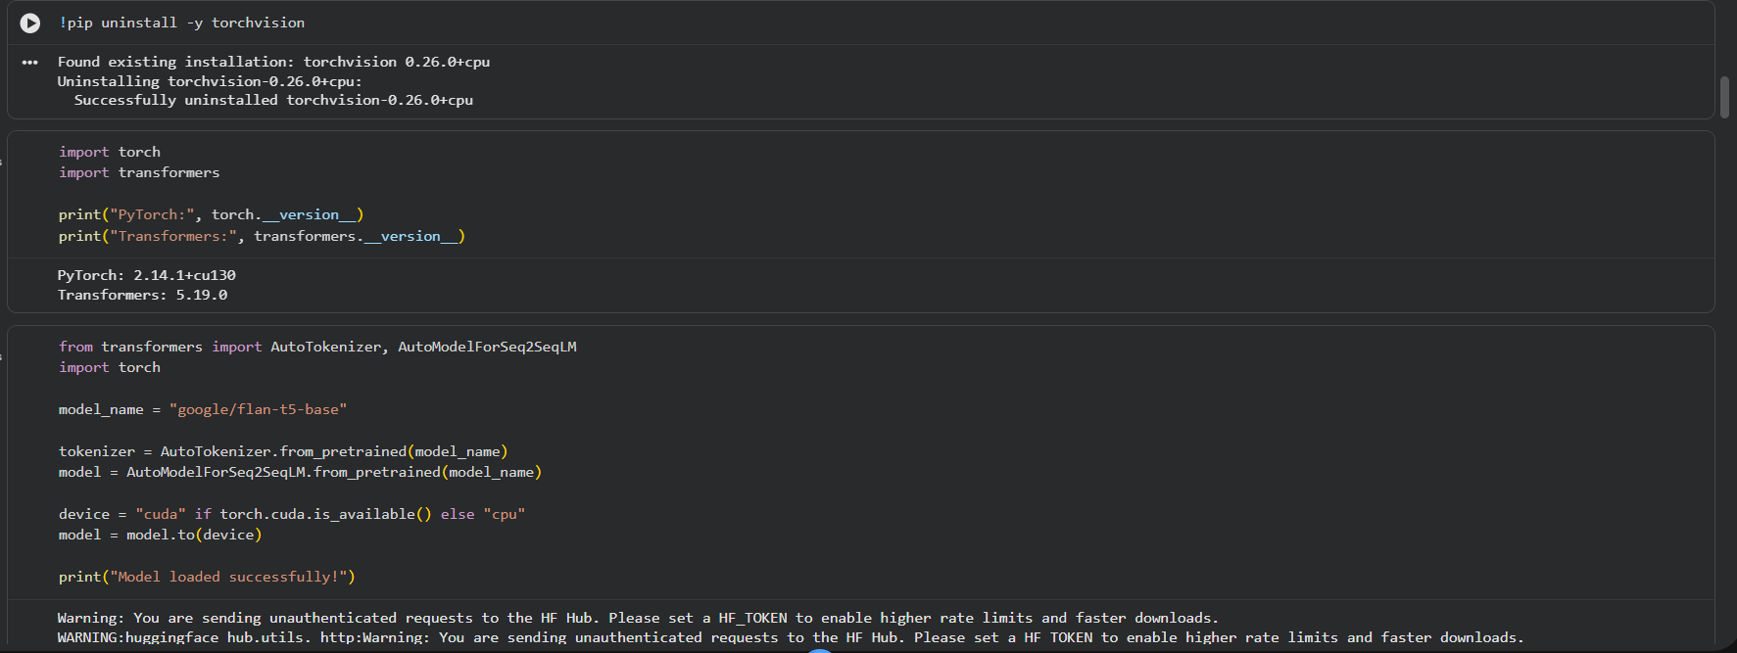
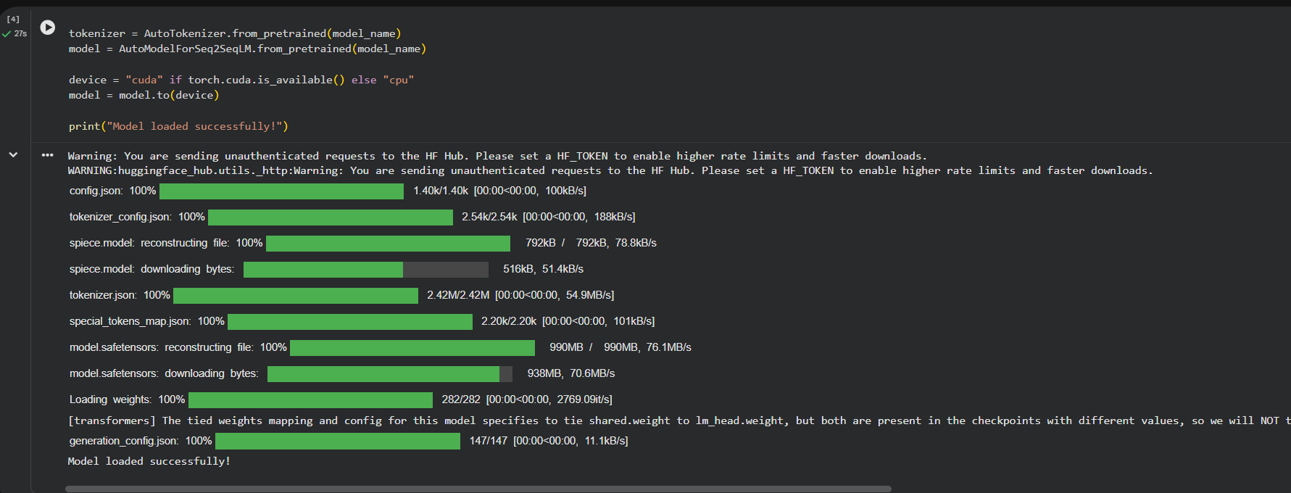
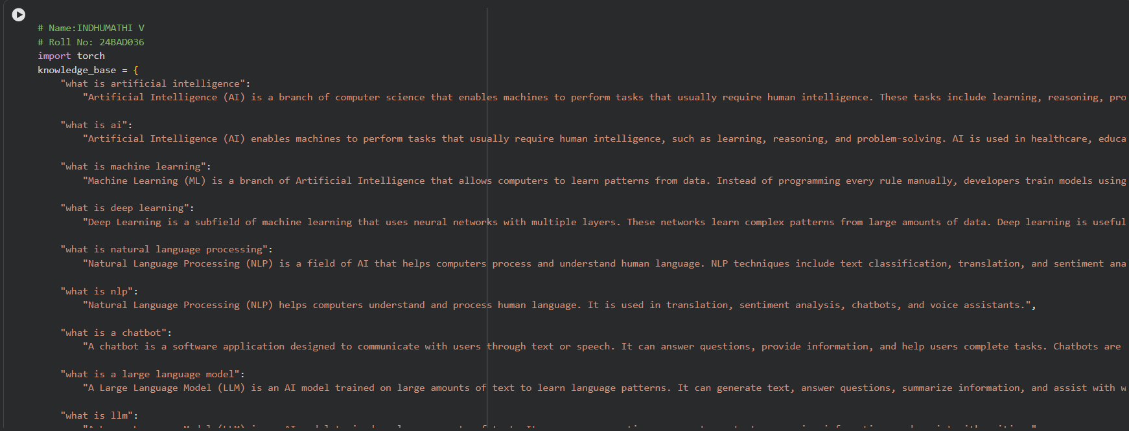
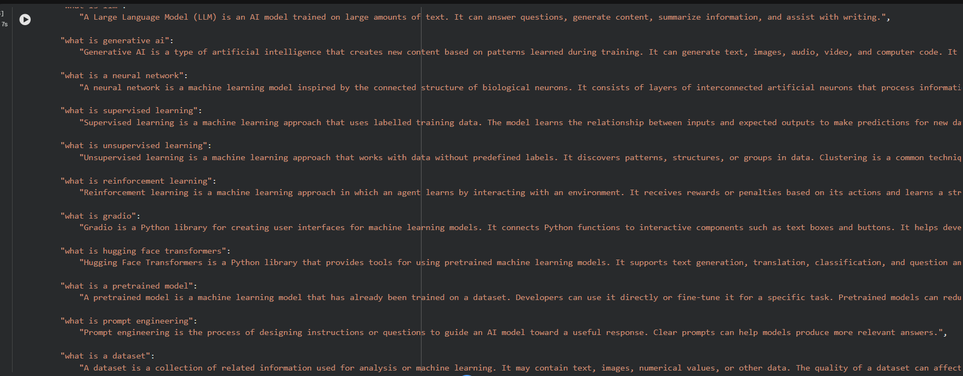
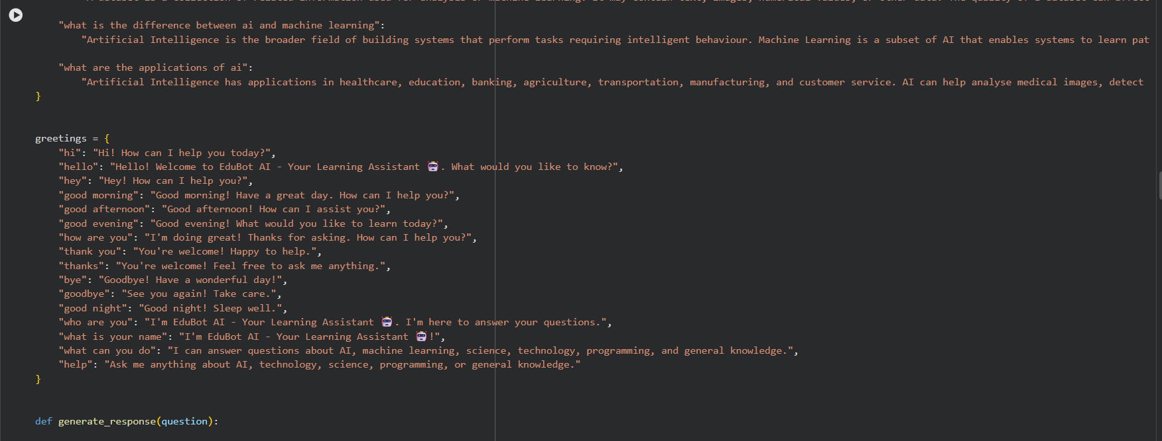
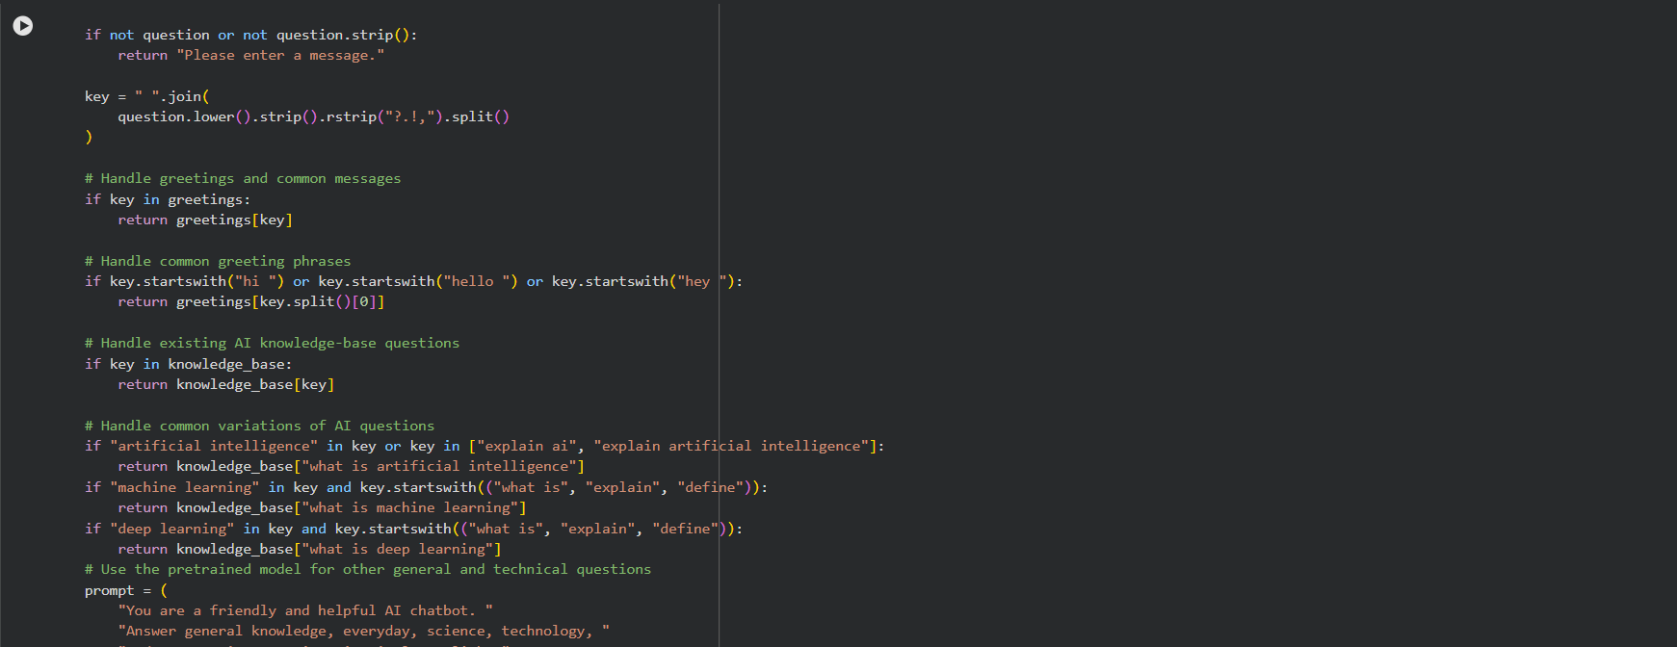
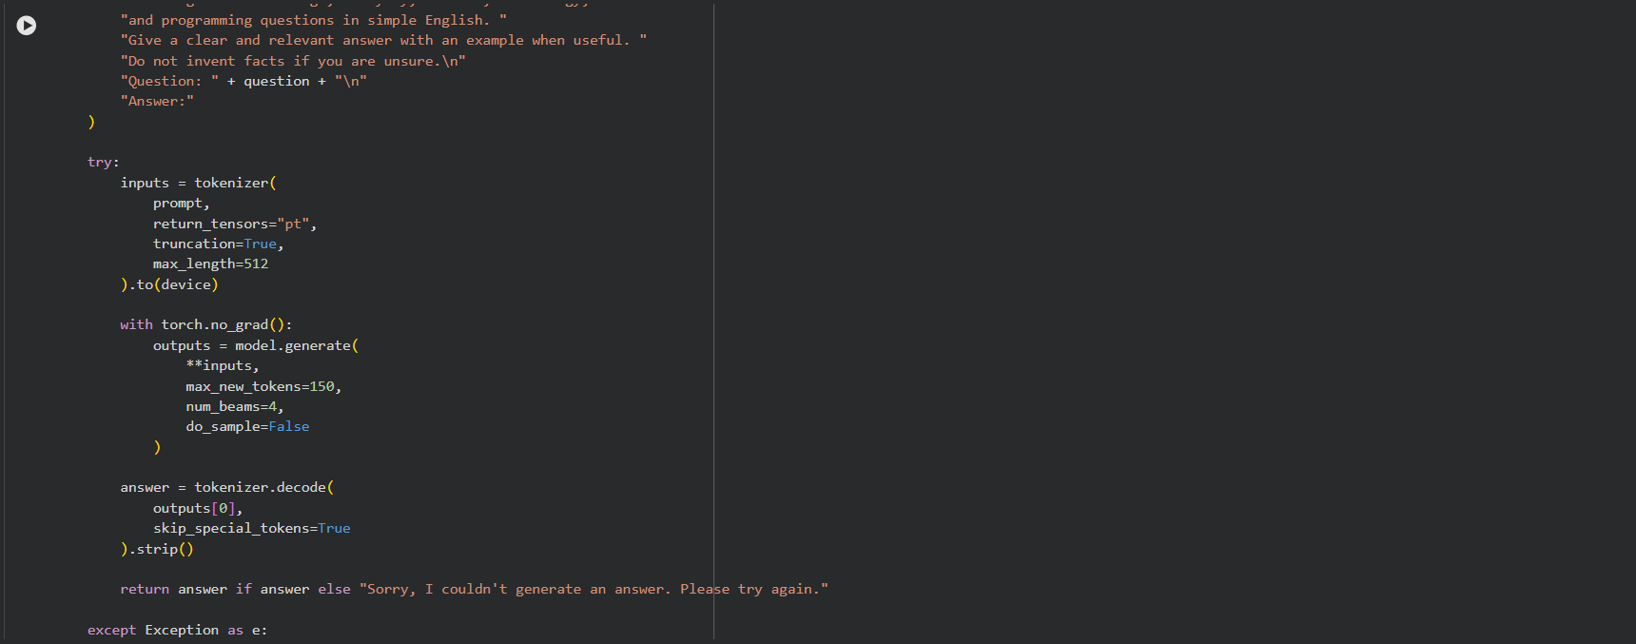
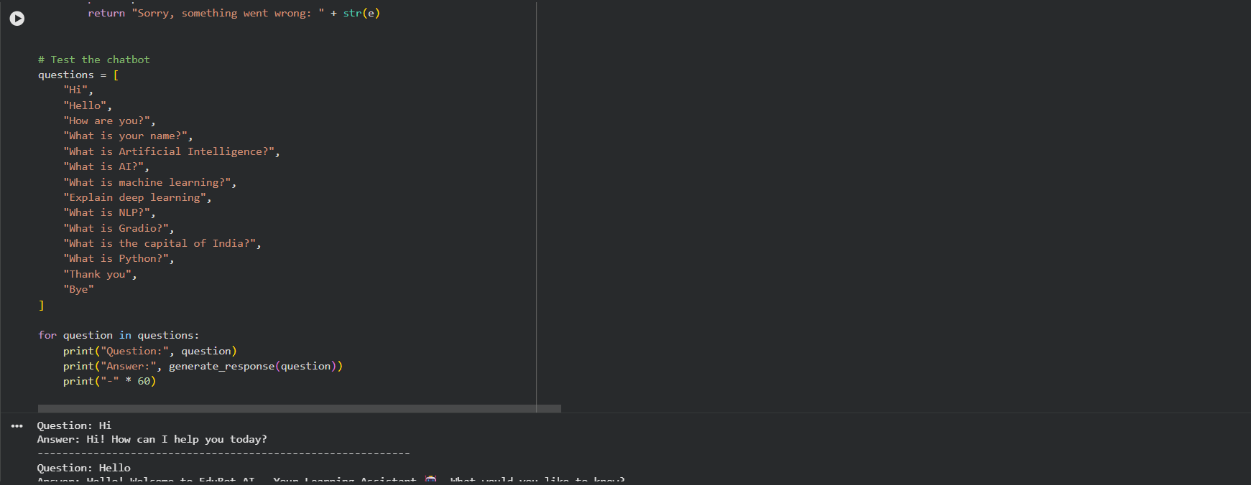
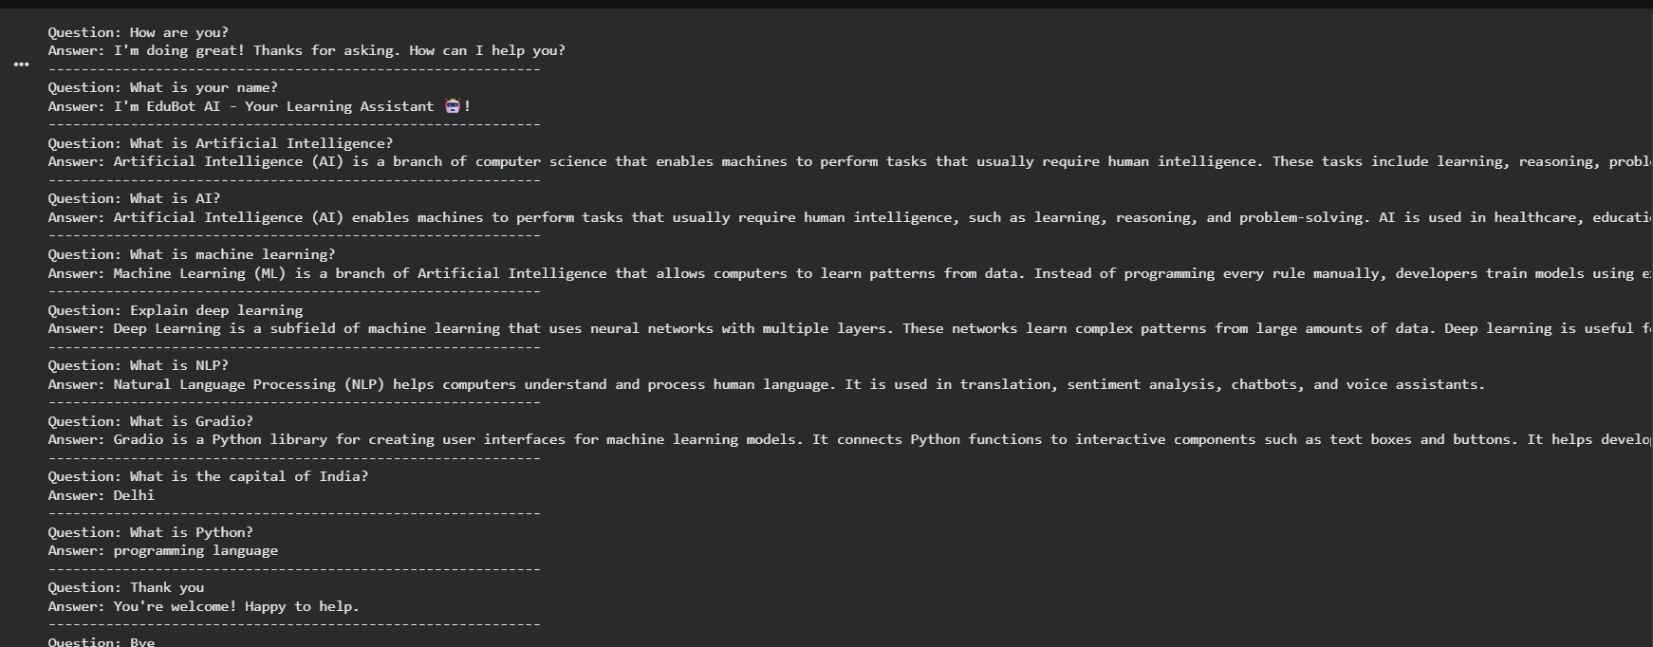
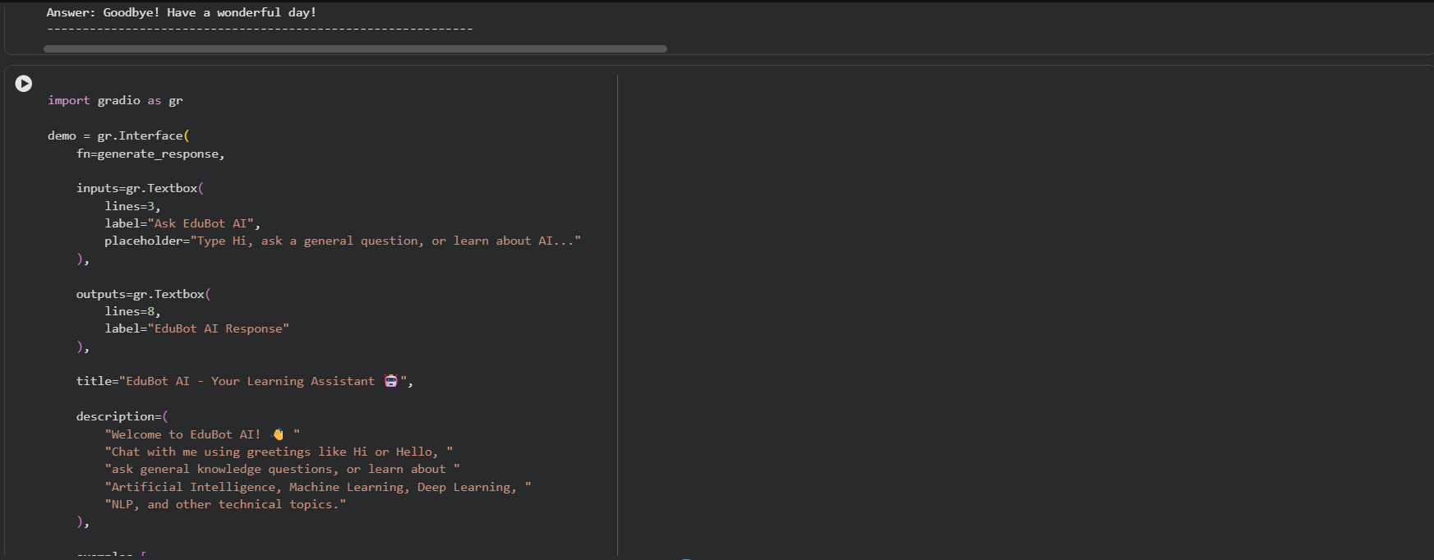
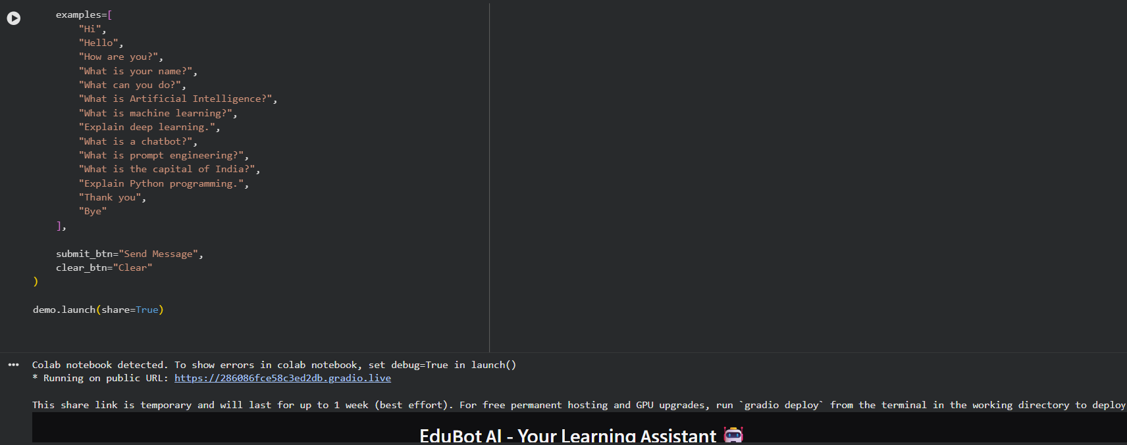
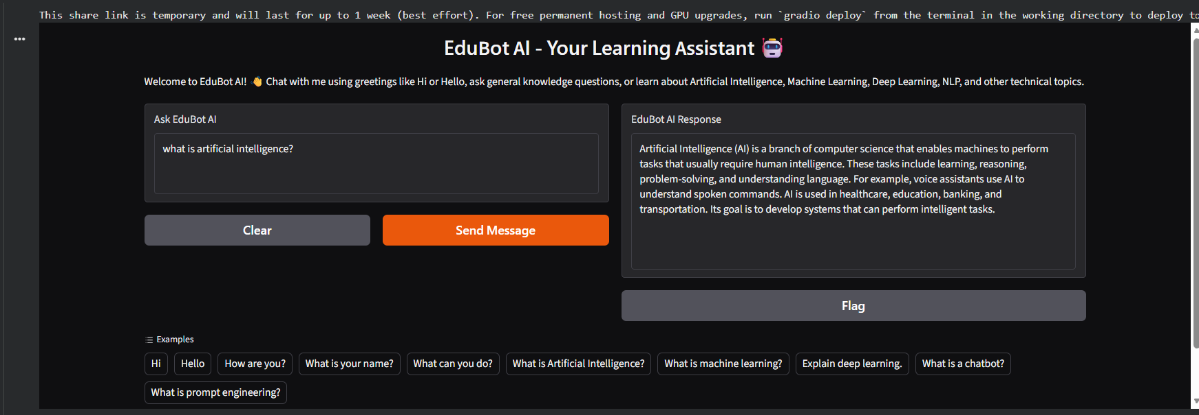

EXPECTED OUTCOME
Students will understand the basic use of Transformer-based LLMs for prompt-based text generation and chatbot development. They will build a working chatbot interface using Streamlit or Gradio, test its responses with different prompts, and run or deploy the application. Students will also identify limitations such as inaccurate responses, model-access requirements, latency, and responsible handling of user inputs and API credentials.

POST-LAB QUESTIONS (PROVIDE BRIEF ANSWERS TO THE FOLLOWING QUESTIONS)

- What is the function of a tokenizer in an LLM application?
A tokenizer converts text into smaller units called tokens. These tokens are converted into numerical values that the LLM can process. It helps the model understand the input text.

- How does a Transformer-based LLM generate a response to a prompt?
The LLM first processes the prompt using the Transformer architecture. The self-attention mechanism helps it understand the context of the input. It predicts the next token based on the previous tokens. This process continues until a complete response is generated.

- What is the purpose of Streamlit or Gradio in this experiment?
Streamlit and Gradio are Python frameworks used to build interactive web applications. They provide a user-friendly interface for AI models. Users can enter prompts and view the generated responses. They make it easy to demonstrate and test chatbot applications.

- Why should an API key be stored securely and not committed to GitHub?
An API key provides access to an external service or AI model. If it is exposed on GitHub, unauthorized users may misuse it. This can lead to security risks and unexpected charges. Therefore, API keys should be stored securely using environment variables.

- What is conversation history, and how can it improve a chatbot?
Conversation history stores previous messages exchanged between the user and chatbot. It helps the chatbot remember the context of the conversation. This allows it to understand follow-up questions. As a result, the chatbot can provide more relevant and consistent responses.

- Mention two limitations of LLM-based chatbots.
LLM-based chatbots may generate incorrect or misleading information. They may also produce biased responses. Their knowledge may not include the latest information. Therefore, important answers should be verified before use.

- How can you test whether a chatbot's responses are relevant?
We can test a chatbot by providing different prompts and questions. The responses should be compared with expected answers. We should check their accuracy, clarity, and relevance. User feedback can also help evaluate the chatbot's performance.

- What is the difference between running an application locally and deploying it online?
Running an application locally means it operates on our own computer. It is generally accessible only within the local environment. Deploying an application online makes it accessible through the internet. Online deployment requires a hosting platform or server.

SUGGESTIONS FOR DATASETS
- Hugging Face Transformers documentation – https://huggingface.co/docs/transformers/index
- Hugging Face conversational / text-generation models – https://huggingface.co/models?pipeline_tag=text-generation
- Streamlit documentation – https://docs.streamlit.io/
- Gradio documentation – https://www.gradio.app/docs

ASSESSMENT
Description | Max Marks | Marks Awarded
Pre Lab Exercise | 5
In Lab Exercise | 10
Post Lab Exercise | 5
Viva | 10
Total | 30
Faculty Signature

